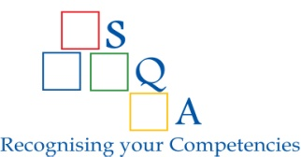
SEYCHELLES QUALIFICATIONS AUTHORITY

Consent Form for Release of Information

I, the undersigned, hereby give my consent that:

- Information regarding my enrolment, academic records and/or awards may be released to the Seychelles Qualifications Authority (SQA) as per my personal details below:

Surname

First Name(s)

Previous Surname (if applicable)

Date of Birth

ID or Passport No.

Qualification | Institution | Date of enrolment/ Award | Student Number
1.

2.

3.

I understand that the purpose of the disclosure of the information is to assist the SQA to process an official request for evaluation, including verification of the authenticity of the above-mentioned qualification(s).

_________________________________ ________________________________
Signature of Qualification Holder Date

SQA is a statutory body established through the SQA Act of 2005. Amongst other functions, the SQA evaluates qualifications to determine their status authenticity and comparability with relevant qualifications recognised on the Seychelles National Qualifications Framework (NQF).

